Task 8:
Aim: To develop an Employee Management module using Spring Core demonstrating Inversion of Control and Dependency Injection using annotations, and managing beans using BeanFactory.
Algorithm:
• Start
• Create a Maven project
• Add Spring dependency in pom.xml
• Create package com.example
• Create classes:
- Employee
- EmployeeService
- AppConfig
- MainApp
• Annotate classes with @Component
• Use @Autowired for dependency injection
• Configure component scanning using @ComponentScan
• Initialize Spring container in MainApp
• Get bean object from container
• Call method to add and display employee data
• Display output on console
• Stop.
Program:
Pom.xml:
<project xmlns="http://maven.apache.org/POM/4.0.0"
xmlns:xsi="http://www.w3.org/2001/XMLSchema-instance"
xsi:schemaLocation="http://maven.apache.org/POM/4.0.0
http://maven.apache.org/maven-v4_0_0.xsd">
<modelVersion>4.0.0</modelVersion>

<groupId>com.example</groupId>
<artifactId>employeeapp</artifactId>
<version>1.0-SNAPSHOT</version>
<dependencies>
<!-- Spring Core -->
<dependency>
<groupId>org.springframework</groupId>
<artifactId>spring-context</artifactId>
<version>5.3.30</version>
</dependency>
</dependencies>
</project>
Employee.java:
package com.example;
import org.springframework.stereotype.Component;
@Component
public class Employee {
private int id;
private String name;
public void setId(int id) {
this.id = id;
}
public void setName(String name) {
this.name = name;
}
public void display() {
System.out.println("ID: " + id + ", Name: " + name);
}
}
EmployeeService.java:
package com.example;
import org.springframework.beans.factory.annotation.Autowired;
import org.springframework.stereotype.Component;
@Component
public class EmployeeService {
@Autowired
private Employee employee;
public void addEmployee(int id, String name) {
employee.setId(id);
employee.setName(name);
employee.display();
}
}
MainApp.java:
package com.example;
import org.springframework.context.ApplicationContext;
import org.springframework.context.annotation.AnnotationConfigApplicationContext;
public class MainApp {
public static void main(String[] args) {
ApplicationContext context =
new AnnotationConfigApplicationContext(AppConfig.class);
EmployeeService service = context.getBean(EmployeeService.class);
service.addEmployee(1, "Mahesh");
service.addEmployee(2, "Ravi");
}
}

Output:
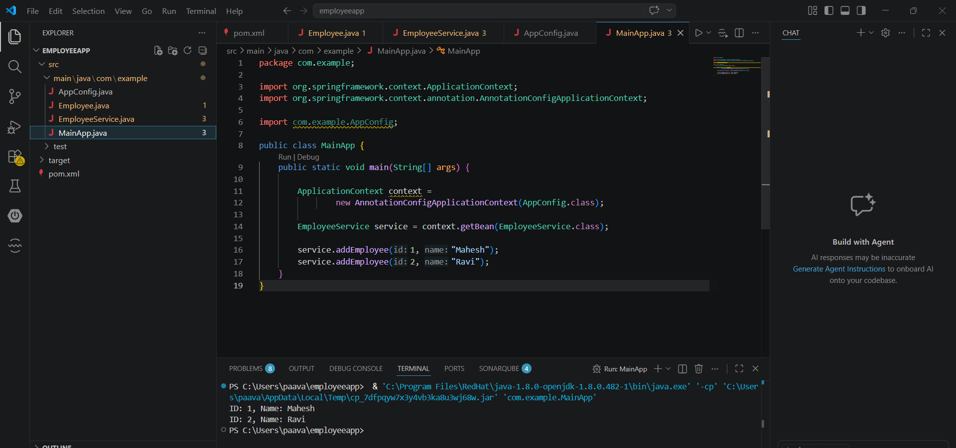

Result: Thus, to develop an Employee Management module using Spring Core demonstrating Inversion of Control and Dependency Injection using annotations, and managing beans using BeanFactory has been executed successfully.

